**UNIVERSITY OF CAPE COAST**

**"HERMES": A GHANA-BASED TOURISM RECOMMENDATION SYSTEM**

**BY**

**AIDOO GIDEON JOJO**

**TUDZI KOFI KAFUI**

**SIMPSON JOSHUA ABEEKU**

**2023**

**UNIVERSITY OF CAPE COAST**

**"HERMES": A GHANA-BASED TOURISM RECOMMENDATION SYSTEM**

**BY**

**AIDOO GIDEON JOJO**

**TUDZI KOFI KAFUI**

**SIMPSON JOSHUA ABEEKU**

Project work submitted to the Department of Computer Science and Information

Technology of the College of Agriculture and Natural Sciences, University of Cape Coast, in partial fulfillment of the requirements for the award of Bachelor of Science degree in Computer Science.

AUGUST, 2023

# DECLARATION

## Candidate’s Declaration

We hereby declare that this project is original research and that no part of it has been presented for another degree in this university or elsewhere.

Candidate’s Signature: ............................................... Date: .........................

Name: Aidoo Gideon Jojo

Candidate’s Signature: ............................................. Date: ..........................

Name: Tudzi Kofi Kafui

Candidate’s Signature: .............................................. Date: .........................

Name: Simpson Joshua Abeeku

## Supervisor’s Declaration

I hereby declare that the preparation and presentation of the project work were supervised in accordance with the guidelines on supervision of the project work laid down by the University of Cape Coast.

Supervisor’s Signature: ….........................................

Name: Dr. Charles Roland Haruna

ABSTRACT

Obtaining valuable and accurate tourism information can become an overwhelming task to tackle given the vast pool of options available to the consumer. Having a plethora of options with no clear guidelines on how to manage and narrow down choices presents a challenge that can be unwanted for many looking to plan trips and activities in the future. Creating a streamlined option to eliminate these issues is hence a worthwhile endeavor. The objective of this project is to develop a recommendation system for a tourism website that provides personalized recommendations to users based on their travel preferences, behavior, and taste. The recommendation system was built using a combination of collaborative filtering and content-based filtering algorithms, Python, HTML, and CSS, and a relevant dataset that was referenced for this project.

Keywords—tourism, recommendation system, travel, website, python, dataset, flask, folium, pandas, folium, scikit-learn.

# ACKNOWLEDGMENT

First, we would like to express our gratitude to our Mentor and Supervisor, Dr. Charles Roland Haruna, who was a continual source of inspiration. He pushed us to think imaginatively and urged us to do this project without hesitation. His vast knowledge, extensive experience, and professional competence in Data Science enabled us to accomplish this project. This endeavor would not have been possible without his help and supervision. We could not have asked for a finer mentor in our studies. This initiative would not have been a success without the contributions of everyone always there to cheer each other on, and that is what kept us together until the end.

We would like to thank The University of Cape Coast for providing us with the opportunity to work on the project ("HERMES": A GHANA-BASED TOURISM RECOMMENDATION SYSTEM). Finally, we would like to express our gratitude to the Department of Computer Science, and friends for their invaluable assistance, and we are deeply grateful to everyone who has contributed to the successful completion of this project.

# DEDICATION

To our parents and loved ones

TABLE OF CONTENTS

**DECLARATION** ii

**ABSTRACT** iii

**ACKNOWLEDGMENT** iv

**DEDICATION** v

**LIST OF FIGURES** x

**LIST OF TABLES** xi

**CHAPTER ONE** 1

INTRODUCTION 1

1.1 Background to the Study 1

1.2 Statement of the Problem 2

1.3 Research Questions 2

1.4 Research Goal and Objectives 3

1.5 Research Scope 3

1.6 Significance of The Study 3

1.7 Limitations 4

CHAPTER TWO 5

2.1 Introduction 5

2.2 Challenges and Opportunities in Tourism Recommendation Systems 5

2.3 Types of Recommendation Algorithms in Tourism Systems 7

2.4 User Satisfaction and Engagement in Tourism Recommendation Systems 8

2.5 Integration of User-Generated Content in Recommendation Systems 9

2.6 Ethical Considerations in User Data Collection and Utilization 11

2.7 Summary 12

CHAPTER THREE 13

METHODOLOGY 13

3.1 Introduction 13

3.2 How Software Development Life Cycle (SDLC) 17

3.3 Software Development Life Cycle Models 19

3.4 How the Agile Model Was Applied 19

3.4.1 Phase 1: Importing Libraries and Setting Up Flask 19

3.4.2 Phase 2: Data Preparation 20

3.4.3 Phase 3: Defining Recommendation Functions 20

3.4.4 Phase 4: Flask Routes and Views 20

3.4.5 Phase 5: Map Visualization 20

3.4.6 Phase 6: HTML Templates 21

3.4.7 Phase 7: Integration of Flask and HTML 21

3.4.8 Phase 8: User Interaction and Testing 21

CHAPTER FOUR 22

PROJECT DESCRIPTION AND IMPLEMENTATION 22

4.1 Introduction 22

4.2 Requirement Gathering and Analysis 22

4.2.1 User Requirements 22

4.2.2 System Requirements 23

4.2.3 Functional Requirements of the System 23

4.2.4 Non-Functional Requirements of the System 25

4.3 Algorithm 27

4.3.1 Algorithm 1 27

4.3.1.1 Algorithm 1 In-depth Explanation 27

4.3.2 Algorithm 2 30

4.3.2.1 Algorithm 2 In-depth Explanation 32

4.4 System Architecture 34

4.5 System Features 37

4.5.1 Index Page 37

4.5.2 Hottest Spot Page 38

4.5.3 Contact Us Page 39

4.5.4 Result Page 40

4.6 Summary 41

CHAPTER FIVE 42

EXPERIMENTATION AND ANALYSIS 42

5.1 Introduction 42

5.2 The Speed of Execution 42

5.2.1 Graph Analysis 42

5.3 User Satisfaction 45

5.3.1 Data Collection 45

5.3.2 Data Results 45

5.3.2.1 Participants 46

5.3.2.2 Tourism Recommendation System 47

5.3.2.3 Movie Recommendation System 54

5.3.2.4 Summary 61

5.4 Conclusion 62

CHAPTER SIX 63

CONCLUSION AND FURTHER RECOMMENDATION 63

6.1 Conclusion 63

6.2 Recommendations for Future Works 63

References 65

# LIST OF FIGURES

Figure 3. 1 Screenshot of the data set 14

Figure 3. 2 Interface of web application 15

Figure 3. 3 Results of recommended places. 16

Figure 3. 4 Map virtualization of the recommended places 16

Figure 3. 5 The Software Development Cycle 17

Figure 4. 1 File structure of the system. 35

Figure 4. 2 Flow chart of the system. 36

Figure 4. 3 Screen Shot of Index Page 37

Figure 4. 4 Explanation of Categories. 38

Figure 4. 5 Screenshot of Footer. 38

Figure 4. 6 Screenshot of Hottest Spot Page 39

Figure 4. 7 Screenshot of Contact Us Page 40

Figure 4. 8 Screenshot of Result Page 40

Figure 4. 9 Screenshot of Result Page Map 41

Figure 5. 1 Graph of Dataset against Execution Time of Tourism Recommendation System 43

Figure 5. 2 Graph of Dataset against Execution Time of Movie Recommendation System 44

Figure 5. 3 Graph of Gender 46

Figure 5. 4 How frequently do you use a recommendation system? 47

Figure 5. 5 On a scale from 1 to 5, how easy was it to understand and navigate the recommendation system? 47

Figure 5. 6 How accurate were the recommendations provided by the system? 48

Figure 5. 7 Were the recommended items relevant to your interests or needs? 49

Figure 5. 8 How satisfied are you overall with the recommendation system? 50

Figure 5. 9 Would you recommend our recommendation system to others? 51

Figure 5. 10 Do you have any suggestions or features you would like to see added to the recommendation system? 52

Figure 5. 11 What aspects of the recommendation system do you think need improvement? 53

Figure 5. 12 On a scale from 1 to 5, how easy was it to understand and navigate the recommendation system? 54

Figure 5. 13 How accurate were the recommendations provided by the system? 55

Figure 5. 14 Were the recommended items relevant to your interests or needs? 56

Figure 5. 15 How satisfied are you overall with the recommendation system? 57

Figure 5. 16 Would you recommend our recommendation system to others? 58

Figure 5. 17 Do you have any suggestions or features you would like to see added to the recommendation system? 59

Figure 5. 18 What aspects of the recommendation system do you think need improvement? 60

Figure 5. 19 Positive Graph 62

LIST OF TABLES

Table 4. 1 The dataset looks alike. 32

Table 4. 2 The dataset after processing. 32

Table 4. 3 Random sample data after user input 33

Table 4. 4 List of data after sorting and selecting similar locations. 33

Table 4. 5 The list after it considers the number of locations. 34

Table 5. 1 Dataset against Execution Time of Tourism Recommendation 42

Table 5. 2 Dataset against Execution Time of Movie Recommendation System 43

Table 5. 3 Positive Dataset 61

# 

# CHAPTER ONE

## INTRODUCTION

## 1.1 Background to the Study

Tourism is a major economic driver, generating billions of dollars in revenue each year. In 2019, the global tourism industry generated $1.9 trillion in revenue and supported 334 million jobs (WTTC, 2019).

The tourism industry is constantly evolving, and one of the most significant trends in recent years has been the rise of online travel agencies (OTAs). OTAs have made it easier than ever for tourists to find and book travel destinations and activities. However, the sheer volume of information available on OTAs can be overwhelming, and it can be difficult for tourists to find the right matches for their interests.

This is where a tourism recommendation system can help. A tourism recommendation system is a software application that uses artificial intelligence to recommend destinations and activities to tourists. The system considers the tourist's interests, and travel preferences to generate personalized recommendations.

There are several factors that can be considered when designing a tourism recommendation system. These factors include:

The type of data that the system will use. The system will need to access data on tourist destinations, activities, and prices.

The algorithms that the system will use to generate recommendations. There are a few different algorithms that can be used for this purpose, such as collaborative filtering and content-based filtering.

The user interface of the system. The system should be easy to use and understand, and it should be tailored to the needs of the target audience.

The tourism recommendation system that will be developed in this study will use a combination of collaborative filtering and content-based filtering algorithms. The system will be designed to recommend destinations and activities to tourists who are traveling to a specific city. The system will also be designed to consider the tourist's travel history and other personal preferences.

## 1.2 Statement of the Problem

The current process of finding and booking travel destinations and activities can be time-consuming and frustrating. Tourists must often spend hours researching different options, and they may still not find the perfect match.

A tourism recommendation system can help to solve this problem by providing tourists with personalized recommendations that are tailored to their specific needs. This can save tourists time and money, and it can help them to have a more enjoyable and memorable travel experience.

## 1.3 Research Questions

The following research questions will be addressed in this study:

* How can a tourism recommendation system be designed to generate personalized recommendations for tourists?
* What are the factors that should be considered when designing a tourism recommendation system?
* How can a tourism recommendation system be evaluated?

## 1.4 Research Goal and Objectives

* The goal of this study is to design and evaluate a tourism recommendation system that can help tourists to find the right destinations and activities to suit their interests. The specific objectives of the study are to:
* Identify the factors that should be considered when designing a tourism recommendation system.
* Design a tourism recommendation system that takes factors in the tourist's interests, and travel needs.
* Evaluate the tourism recommendation system to assess its effectiveness.

## 1.5 Research Scope

The scope of this study is limited to the design and evaluation of a tourism recommendation system. The system will be designed to recommend destinations and activities to tourists who are traveling to a specific city. The system will not be designed to recommend destinations and activities for tourists who are traveling to multiple cities or countries.

## 1.6 Significance of the Study

The results of this study will have the following significance:

* The study will provide insights into the design of tourism recommendation systems.
* The study will provide a tool that can help tourists to find the right destinations and activities to suit their interests.
* The study will help to improve the efficiency and effectiveness of the tourism industry.

## 1.7 Limitations

The following limitations are associated with this study:

* The system will only be able to recommend destinations and activities for tourists who are traveling to a specific region.
* The system will not be able to consider the tourist's travel history or other personal preferences.
* The system will not be able to recommend destinations and activities that are out of the tourist's budget.

# CHAPTER TWO

LITERATURE REVIEW

## 2.1 Introduction

As it pertains to tourism, there are many options that are available to those who are looking to explore new areas of the world. Traditional tourism methods such as package tours arranged by external travel agencies, or hiring tour guides might not be the best option for some travelers. When tour guides show an affinity for having good problem-solving skills and knowledge, tourist satisfaction typically shows a negative trend as opposed to the tour guide displaying more desirable traits such as interpersonal communication and organizational skills (Kuo, Cheng, Chang, & Chuang, 2018). (Yin & Poon, 2016)argue that the negative behavior of other members on package tours negatively affects the satisfaction levels that tourists report after the occasion. Many seek to avoid these issues by creating travel plans themselves. A solution to their issues can be presented through a tourism recommender service that can help guide tourists if they seek to create their own path to follow.

## 2.2 Challenges and Opportunities in Tourism Recommendation Systems

The field of tourism recommendation systems presents a myriad of challenges and opportunities, particularly when designing systems tailored for specific regions. Tourism recommendation systems face unique challenges compared to traditional recommender systems. (Dareddy, 2016)outlines several key challenges, including dynamic itinerary planning, integrating mobile platforms, developing evaluation methods, providing group recommendations, incorporating social networks, achieving serendipity, modeling users, ensuring privacy, and building robust systems. However, the tourism domain also presents many opportunities for improvement through personalization and filtering substantial amounts of data. While these systems offer valuable assistance to travelers, their effectiveness is influenced by factors such as the diversity of destinations, cultural nuances, and variations in user preferences. Crafting high-quality recommendations is challenging due to the diversity of destinations and the cultural differences between users that shape how they experience and evaluate places. Some studies have found that incorporating multiple criteria, like affordability, safety, and availability of activities, into recommendation systems can improve their effectiveness. (Alrasheed, Alzeer, Alhowimel, Alshameri, & Althyabi, 2020)proposes a multi-level recommender system framework that first provides a list of destinations liked by similar users, and then ranks them based on the user’s inputs. Similarly, (Ojha & Mishra, 2018)use multi-criteria decision-making to recommend destinations aligned with tourists’ preferences. Culture is another key factor that influences how people experience destinations. (Hong & Jung, 2021) developed tensor models that consider both multiple criteria and cultural groups, finding that these improve recommendation accuracy, especially when distinguishing between Western and Eastern cultures. Scholars have emphasized the importance of balancing customization and generalization to keep recommendations relevant while recognizing cultural and individual diversity in travel expectations. There is a consensus that personalization of services and products should strike a balance between customization tailored to individual needs and generalization that remains universally applicable (Not & Petrelli, 2014; Musterd & Kovacs, 2013; Thomann, 2018). Customization allows for relevance but risks becoming overly niche, while generalization promotes inclusiveness at the cost of precision. In the context of travel and transportation, customization is key to providing recommendations and itineraries that match travelers’ diverse interests, styles, and constraints (Erbil & Wörndl, 2022; Mohan, Klenk, & Bellotti, 2019; Mahdi, Soui, & Abed, 2014). Furthermore, the growth of user-generated information on websites like social media has created opportunities for utilizing current, accurate data to improve the timeliness and quality of recommendations. Several studies have shown how this real-time data from platforms like Twitter and Facebook can be leveraged to improve the accuracy and timeliness of recommendation systems. (Narducci, Musto, Semeraro, Lops, & de Gemmis, 2013) argues that the "explosion of Big Data" from social networks offers new opportunities for personalized recommendations. The masses of data people share about their "preferences, feelings, and friendships" can help address the "cold start problem" of recommender systems by providing information to build user profiles. Creating these user profiles is one way of enabling a tourism recommendation site to generate a more personalized output.

## 2.3 Types of Recommendation Algorithms in Tourism Systems

Tourism recommendation systems are tailored to leverage various recommendation algorithms to achieve more accurate and personalized recommendations for individuals over time, with collaborative filtering and content-based filtering standing out as the most prominent approaches. Collaborative filtering, in its most simple form, makes recommendations to active users based on what other users with similar tastes to the active user have liked in the past (Ricci, Rokach, & Shapira, 2015). In the case of something like a tourism recommendation system, it employs user behavior patterns to suggest destinations or activities that align with similar users' preferences. It is sometimes referred to as “people-to-people correlation.” Content-based filtering, on the other hand, recommends items that are like ones that a user has liked in the past, and this approach aims to match attributes of the user profile to attributes of the items that it recommends (Ricci et al., 2015). In tourism, it relies on attributes and characteristics of items, such as tourist attractions or accommodations, to generate recommendations. Researchers have explored hybrid models that combine these approaches to overcome their respective limitations, resulting in more accurate and diverse recommendations that cater to individual preferences while also introducing novel options. The advantages of content-based attempts to cover the deficiencies of collaborative filtering and vice versa (Ricci et al., 2015).

## 2.4 User Satisfaction and Engagement in Tourism Recommendation Systems

The success of tourism recommendation systems is measured not only by their accuracy but also by user satisfaction and engagement. According to research, delivering individualized recommendations has a substantial impact on consumers' decision-making processes and improves their overall travel experiences. Personalized travel recommendations have been shown to improve users' travel planning and experiences (Badouch & Boutaounte, 2023) found that machine learning algorithms that analyze user data to generate personalized recommendations are highly effective. These algorithms can suggest destinations, attractions, accommodations, and activities tailored to users' preferences and past behaviors, simplifying trip planning, and enhancing the overall experience (Tintarev, Flores, & Amatriain, 2010) discovered that personalized POI recommendations led participants to visit more places overall and discover hidden gems "off the beaten track", increasing serendipitous findings and satisfaction, especially for returning tourists. Participants were just as happy with personalized recommendations of rarer places as with popular recommendations. Maintaining elevated levels of user satisfaction, on the other hand, demands striking a delicate balance between familiar recommendations that match user preferences and introducing serendipitous options that encourage exploration. Some papers present compelling evidence that balancing familiarity and serendipity is key to user satisfaction. Familiar recommendations that match known interests provide short-term satisfaction but risk trapping users in a “filter bubble” (Matt, Benlian, Hess, & Weiß, 2014). Introducing serendipitous options sparks curiosity and helps users discover new interests, increasing long-term satisfaction (Chen, Yang, Wang, Yang, & Yuan, 2019; Niu & Al-Doulat, 2021). However, serendipity comes with risks if options do not match tastes (Schnabel, Bennett, Dumais, & Joachims, 2018). Several studies found that serendipity significantly improves user satisfaction.

## 2.5 Integration of User-Generated Content in Recommendation Systems

The integration of user-generated content, such as reviews and ratings, has emerged as a powerful tool to augment the accuracy and authenticity of tourism recommendations. User-generated content (UGC) like online reviews and ratings has become an invaluable resource for tourists and tourism businesses. Multiple studies have found that UGC significantly impacts tourists' decision-making and business performance (Alnogaithan, Algazlan, Aljuraiban, & Shargabi, 2019) proposes a recommendation system that analyzes user reviews to provide personalized recommendations for tourists. This form of data collection is valuable to both organizations and consumers because it provides data that is unfiltered by traditional media outlets (Krumm, Davies, & Narayanaswami, 2008). (Rossetti, Stella, & Zanker, 2016) Describes how topic modeling of reviews can provide useful insights for both tourists and businesses. Present-day recommendation systems focus on the metadata or the previous consumption behavior to select the content but do not consider contextual information or social network relations (De Pessemier, Deryckere, Tom, & Martens, 2009). Researchers have also explored the sentiment analysis of user-generated reviews to identify hidden preferences and sentiments that may not be explicitly expressed. Sentiment analysis of online user reviews is an active area of research that aims to uncover consumers' opinions and attitudes (Teh, Pak, Rayson, & Piao, 2015) shows it is possible to determine seven levels of sentiment from formatting features like capital letters and emoticons (Basiri, Ghasem-Aghaee, & Naghsh-Nilchi, 2014) finds that considering reviewers’ comment histories and the theory of negativity bias can improve sentiment analysis. This approach not only refines recommendation accuracy but also fosters user trust, as recommendations are informed by the experiences and perspectives of fellow travelers. One should also be wary of the inconclusive nature of reviews and how sentiment analysis can further analyze them (Lak & Turetken, 2017) found that sentiment analysis scores on reviews can negatively impact purchase decisions by causing people to make faster but less confident choices (Garcia & Yin, 2015) also noted that review scores do not always accurately reflect customers’ actual experiences or satisfaction.

However, with all the optimistic points mentioned, ethical considerations related to the authenticity of user-generated content and potential biases in online reviews warrant careful attention.

## 2.6 Ethical Considerations in User Data Collection and Utilization

In tourism recommendation systems, the collecting and use of user data raises ethical considerations. Personalization is based on user data and academics and practitioners must deal with issues of privacy, permission, and data security. The more user data that is available to use, the more personalized and accurate certain recommendations will be for individuals. Thus, any kind of system needs to be explicit to users about the kinds of data they are collecting, how that data is stored, and how it may affect the users (Valentine, D’Alfonso, & Lederman, 2022). Recommender systems must also be wary of the sensitivity of user information. (Valentine et al., 2022) again argues that user data must be treated with the same attention and care as medical records which helps to guide those who collect such data in the absence of robust legislature protecting such data in the current landscape. Striking a balance between delivering tailored recommendations and safeguarding user privacy requires transparent communication about data usage, as well as the implementation of robust data protection measures. The European Union (EU) sets a valuable example for all with the General Data Protection Regulation (GDPR) which came into effect in May 2018. The legislation was passed with the aim of giving users more control of who can access their data and, providing more concrete rules for organizations to abide by (Tikkinen-Piri, Rohunen, & Markkula, 2018). Responsible data handling not only increases user trust but also supports the long-term viability of tourism recommendation systems.

## 2.7 Summary

Tourism recommendation systems can now be seen as a complex subject to tackle effectively. Traditional tourism methods may not suit all travelers, leading to a need for self-planned travel. The literature suggests using tourism recommender services to assist such travelers. Tourism recommendation systems face challenges like dynamic itinerary planning, cultural differences, and user diversity. Studies propose multi-level recommender systems and cultural-aware models to address these challenges. Balancing customization and generalization are crucial. Two prominent recommendation approaches are collaborative filtering and content-based filtering. Hybrid models combining these methods are explored to enhance the accuracy and diversity of recommendations. Personalized recommendations impact user satisfaction and engagement. Research shows that tailored suggestions lead to improved travel planning and experiences, but a balance between familiarity and serendipity is vital. Integrating user-generated content, such as reviews and ratings, enhances recommendation authenticity. Sentiment analysis of reviews uncovers hidden preferences. However, ethical considerations and biases in online reviews need attention. User data collection and utilization in tourism recommendations raise ethical concerns. Transparency and privacy are crucial, and lessons can be learned from GDPR in the EU, and responsible data handling builds user trust and ensures the long-term viability of these systems.

# CHAPTER THREE

## METHODOLOGY

## 3.1 Introduction

In the era of knowledge, it can be difficult for tourists to choose the best vacation spots based on their preferences and interests. The project being presented develops a tourist destination recommender system to address this problem. By combining machine learning, natural language processing, and content-based filtering, this system suggests tourist attractions that closely match the categories and regions that users have selected, below are the steps to get the tourism recommendation system all in one piece:

* **Data Preparation and Processing**

To start, the system obtains its data from a publicly available dataset that includes thorough data about a variety of tourist sites. Essential features such as place names, categories, regions, descriptions, coordinates, and ratings have been carefully selected for inclusion in this collection. A preprocessing workflow is used when the dataset is imported using the pandas package to increase its usefulness for recommendations. Concatenating category and description information into a single "Tags" column provides the data with semantically significant textual elements for later analysis.

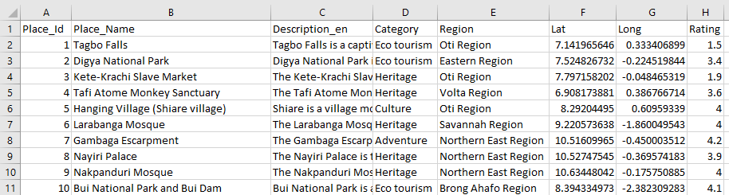

Figure 3. 1 Screenshot of the data set

* **Content-Based Filtering and Similarity Calculation**

The basis of the recommendation process is content-based filtering, which uses the TF-IDF (Term Frequency-Inverse Document Frequency) vectorization technique to convert textual data into a numerical representation. While discounting frequently used keywords, this transformation captures the significance of words inside descriptions and categories. The degree of similarity between various tourist locations is then determined using cosine similarity based on their TF-IDF vectors. This similarity matrix serves as the foundation for locating locations that have comparable thematic and semantic characteristics.

* **User Interaction via Web Application**

Flask, a micro web framework, is used to power a web application that increases the system's usability. The user-friendly layout of this program enables users to enter their preferred category, region, and the desired quantity of recommendations. The program uses the content-based filtering technique to offer a list of travel destinations that meet the given criteria after receiving these inputs. Additionally, using the Folium library, a geographical map is dynamically created with markers placed on it about the suggested places.

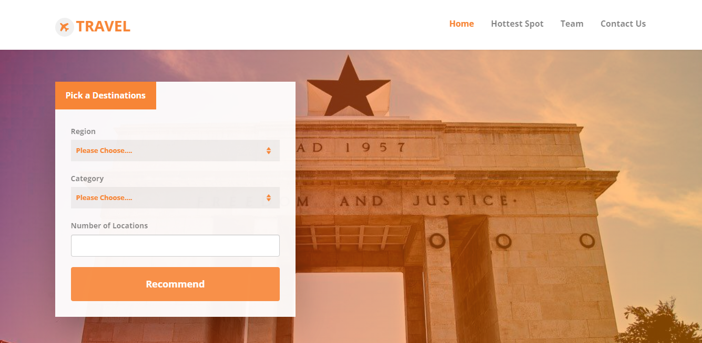

Figure 3. 2 Interface of web application

* **Presentation and Visualization**

Users are shown the results of the recommendation process in an HTML format, where each suggested location is included along with its name, category, star rating, and a brief description. Links are given so that you can access additional external resources for your research. Additionally, the interactive map that is integrated into the results page improves the user experience by graphically illustrating the locations of the suggested places.

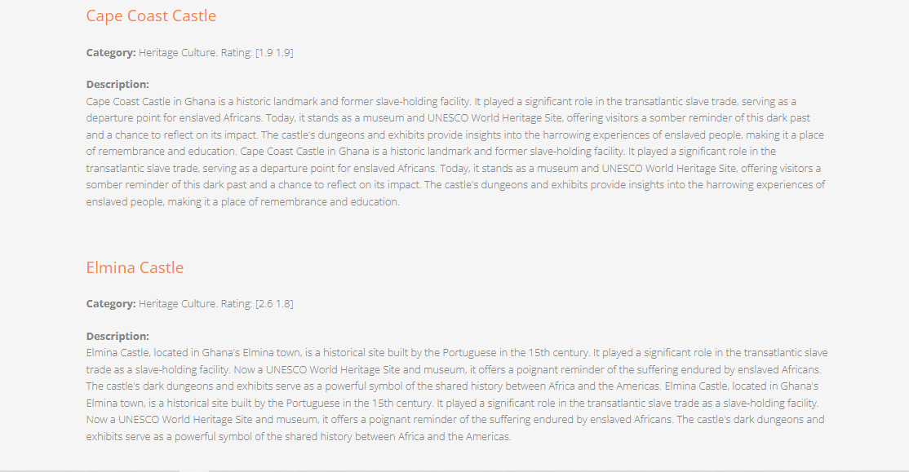

Figure 3. 3 Results of recommended places.

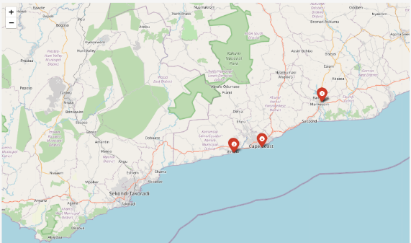

Figure 3. 4 Map virtualization of the recommended places

## 3.2 How Software Development Life Cycle (SDLC)

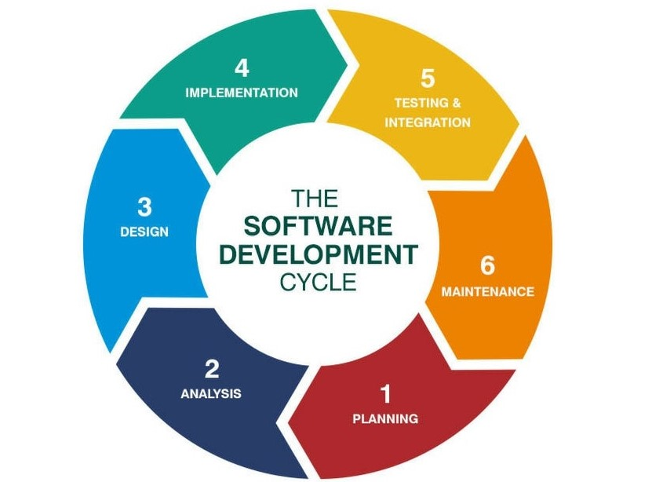

Figure 3. 5 The Software Development Cycle

1. **Planning**

The Tourist Recommender System's scope and project objectives are both described in the planning stage. A recommendation system based on user preferences and location is determined to be necessary by the team. They outline the system's objectives, specifications, and limitations, as well as its data sources, functionality, and user interface layout.

1. **Analysis**

During the analysis phase, the team conducts a detailed analysis of the requirements. They gather data about tourist destinations, including place names, categories, descriptions, coordinates, and ratings. They analyze the relationships between different attributes to understand how the recommendation system can effectively match user preferences with available destinations.

1. **Design**

The design phase involves creating the architectural and functional design of the system. The team designs the data preprocessing pipeline to merge category and description data, enhancing the recommendation engine's accuracy. They design the content-based filtering mechanism using TF-IDF vectorization and cosine similarity. Additionally, they design the web application's user interface and the map visualization components.

1. **Implementation**

In the implementation stage, the actual coding takes place. The team writes the Python code for data manipulation using pandas, implements the flask-based web application for user interaction, and integrates the folium library for map visualization. They develop the content-based filtering logic, including the recommendation algorithm and the mechanism to calculate cosine similarity.

1. **Testing & Integration**

During testing and integration, the system components are thoroughly evaluated to ensure functionality, accuracy, and compatibility. The team performs unit testing on individual components such as data preprocessing, content-based filtering, and web application modules. Integration testing ensures that all components work seamlessly together, from data retrieval to recommendation display and map visualization.

1. **Maintenance**

After deployment, the system enters the maintenance phase. The team continuously monitors the system's performance, gathers user feedback, and addresses any issues that arise. They make enhancements based on user suggestions, improve recommendation accuracy, and ensure the system remains up to date with changing data sources or technology requirements.

## 3.3 Software Development Life Cycle Models

The selection of a Software Development Life Cycle (SDLC) model is influenced by a few variables, including the project's nature, the team's capabilities, the project's schedule, and the needs of the client. Agile, and specifically the Scrum methodology, was the appropriate SDLC paradigm for the Tourism Recommendation System.

## 3.4 How the Agile Model Was Applied

The group's use of the agile software development paradigm to create web applications is discussed in this section. Utilizing the various stages of the software development cycle methodology, the model was put into practice. There were eight (8) phases in the project.

## 3.4.1 Phase 1: Importing Libraries and Setting up Flask

In this phase, essential libraries are imported, including pandas for data manipulation, folium for map visualization, scikit-learn for similarity calculations, and flask for creating the web application. The flask instance is set up to start building the application's routes and views.

## 3.4.2 Phase 2: Data Preparation

This phase involves loading the tourist spot data from a CSV file hosted on Google Drive. The dataset is processed to combine relevant information and select key columns for analysis. Text data is transformed into numerical features using TF-IDF vectorization, and cosine similarity is calculated between these vectors to measure content-based similarity between spots.

## 3.4.3 Phase 3: Defining Recommendation Functions

In this phase, a recommendation function is defined to generate personalized tourist spot recommendations. The function selects a random sample spot from the chosen category, calculates its similarity to other spots, and identifies the most similar places within the same region. This function forms the core of the recommendation engine.

## 3.4.4 Phase 4: Flask Routes and Views

Routes and views are defined for different pages of the web application. The main route handles user interactions, such as submitting a form to request recommendations. When a user submits the form, the application generates recommendations and displays them on the map, creating an interactive experience for the user.

## 3.4.5 Phase 5: Map Visualization

The map visualization phase focuses on creating an interactive map using Folium. The map is centered on Ghana, and markers are added to indicate recommended tourist spots. Each marker is associated with a tooltip and icon, providing users with information about the recommended locations.

## 3.4.6 Phase 6: HTML Templates

HTML templates are created for various pages of the application. These templates define the structure, styling, and placeholders for dynamic content. Templates ensure a consistent look, feel throughout the application, and enable the integration of Flask-generated content.

## 3.4.7 Phase 7: Integration of Flask and HTML

This phase involves integrating Flask with the HTML templates to dynamically render content. When users access different routes, Flask generates content based on the user's interactions, such as recommendations, map visualizations, and details about tourist spots. The integration of Flask and HTML creates a seamless and responsive user experience.

## 3.4.8 Phase 8: User Interaction and Testing

Users can interact with the application through a web browser. They can input preferences, such as category, city, and the desired number of recommendations. The application generates personalized recommendations, displays them on an interactive map, and provides detailed information about each.

# CHAPTER FOUR

## PROJECT DESCRIPTION AND IMPLEMENTATION

## 4.1 Introduction

This chapter focuses further on the requirements gathering and analysis, specifications of hardware and software, design, implementation as well as the dependencies the system needs, to function correctly. The chapter also displays all the system components and features, using algorithms and a flow chart of the tourism recommendation System. It further discusses the design decisions, implementation, testing, and deployment of the system.

## 4.2 Requirement Gathering and Analysis

The first phase of SDLC is the requirements gathering and analysis. This phase aims to capture in detail the scope of the project, expected issues, function, and non-functional requirements of the software are gathered and examined. Information gathered in this phase will detail the timeline of the project and its feasibility. This stage incorporates the following:

1. User Requirements
2. System Requirements
3. Function Requirements
4. Non-Functional Requirements

### **4.2.1 User Requirements**

The User Requirements describe what users expect the system to be able to do. The following are some user requirements for the system:

* The system should allow users to input their preferred type of tourist spot (e.g., Ecotourism, heritage, cultural) through a dropdown or text field.
* The system should provide a clear and organized list of recommended tourist spots.
* Users should be able to specify the number of tourist spot recommendations they want to receive.

### **4.2.2 System Requirements**

System requirements are the hardware components or other software resources that must be present on a computer for the system to function efficiently. Failure to meet these requirements can result in execution issues and failures as the system is being used.

#### **4.2.2.1 Hardware Requirements**

The hardware requirements are the requirements of a hardware device. Thus, the application server should be able to run on any hardware capable of running Python 3.7 and newer, folium, flask, pandas, and scikit-learn. As the server is expected to respond to a request submitted by users, a constant internet connection is needed before the users can use the program as it is a web-based application.

#### **4.2.2.2 Software Requirements**

The web dashboard can only be accessed with a computer or mobile device that has JavaScript-enabled web browser functionality and supports HTML.

### **4.2.3 Functional Requirements of the System**

**User Input and Submission:**

* Users should be able to input their preferences through a web form.
* The input form should include fields for selecting the type of tourist spot (category), the city, and the number of recommendations.
* Users should be able to submit the form to trigger the recommendation process.

**Tourist Spot Recommendations:**

* The system should use content-based filtering to generate recommendations based on the user's selected preferences.
* Recommendations should include tourist spot names that are like the user's preferences.
* The number of recommended spots should match the user's input.

**Interactive Map Display:**

* The system should display an interactive map using Folium.
* The map should be centered on a predefined location (e.g., Ghana) with a specified zoom level.
* Markers should be placed on the map to represent the recommended tourist spots.
* Each marker should display the name of the recommended spot when clicked.

**Map Marker Coordinates:**

* The system should retrieve the latitude and longitude coordinates of recommended tourist spots from the dataset.
* The coordinates should be used to place markers on the map.

**External Link Integration:**

* The system should generate clickable links that lead to Google search results for each recommended tourist spot.
* Clicking on a link should open a new browser tab with the Google search results page.

**Detailed Information Display:**

* The system should display detailed information about recommended tourist spots alongside the map.
* Information should include the spot's name, category, rating, and description.

**Error Handling:**

* The system should manage cases where the input form is submitted with missing or incorrect data.
* Appropriate error messages should be displayed to guide users in correcting their inputs.

**Dynamic Recommendation Generation:**

* The system should generate new recommendations each time the user submits the form with different preferences.

### **4.2.4 Non-Functional Requirements of the System**

**Usability and User Experience:**

* **User-Friendly Interface**: The web interface should be intuitive, easy to navigate, and provide clear instructions for users.
* **Consistency**: The interface elements, fonts, colors, and layout should be consistent across different pages.

**Performance:**

* **Response Time**: The system should respond to user interactions promptly, ideally within a few seconds.
* **Scalability**: The application should be designed to manage an increasing number of users and recommendations without significant performance degradation.

**Reliability:**

* **Stability:** The system should be stable and minimize crashes or downtime during user interactions.
* **Data Integrity**: The application should ensure the integrity of the dataset and the accuracy of recommendations.

**Security:**

* **Data Protection**: User data and preferences submitted through the form should be securely stored and processed.
* **Access Control**: Access to sensitive parts of the application, such as data processing and administration, should be restricted to authorized users.

**Availability:**

* **Uptime**: The system should aim for high availability, minimizing downtime for maintenance and updates.

**Compatibility:**

* **Cross-Browser Compatibility**: The application should work consistently across different web browsers (e.g., Chrome, Firefox, and Safari).
* **Device Compatibility**: The system should be accessible and usable on various devices, including desktops, tablets, and mobile phones.

**Performance Efficiency:**

* **Resource Utilization**: The application should use system resources efficiently, including memory and processing power.
* **Optimized Loading**: Maps, recommendations, and other components should load quickly to enhance user experience.

## 4.3 Algorithm

The algorithm of the system is in two phases.

* The general basic algorithm to create the recommender system.
* What happens at the background when user inputs specific value.

## 4.3.1 Algorithm 1

*Start*

Step 1: Import necessary libraries.

Step 2: Set up the Flask application.

Step 3: Preparing the dataset.

Step 4: Define the recommend_by_content_based_filtering function.

Step 5: Define the cordinate_plotter function.

Step 6: Define the makeRecommender function.

Step 7: Define the Flask route.

*Stop*

**4.3.1.1 Algorithm 1 In-depth Explanation**

**Step 1**

In this step import the required Python libraries for the web application. Import pandas for data manipulation, folium for creating interactive maps, cosine similarity from scikit-learn for calculating cosine similarity, TfidfVectorizer from scikit-learn for creating TF-IDF vectors, and Flask for building web applications.

**Step 2**

Here, creates an instance of the Flask application with the name 'app'. This will be the foundation of our web application.

**Step 3**

In this step, the dataset was read from a Google Drive link using pandas' read_csv function. The dataset contains information about tourist spots, including their names, descriptions, categories, cities (Region), coordinates (latitude and longitude), and ratings.

**Step 4**

This function takes 'categories', 'regions', and 'number_of_locations' as input and returns a list of recommended tourist spot names.

* First, it randomly samples a data sample from the specified category using pandas' sample function.
* It retrieves the index of the data sample in the DataFrame 'data_content_based_filtering'.
* Then, it finds the similarity scores between the data sample and all other tourist spots using the 'similarity' array.
* The function sorts the similarity scores in descending order and gets the top ninety-nine similar locations (excluding the data sample itself).
* It filters the top locations that match the specified region (city).
* The function then returns a list of recommended tourist spot names.

**Step 5**

This function is responsible for adding a marker to the map at the coordinates of a recommended tourist spot. This helps users visually understand the location of the recommended spots on the map. Each marker provides additional information (name of the spot) as a popup and hovering over the marker displays the name as a tooltip.

**Step 6**

This function takes the recommendation (list of recommended tourist spots) as input and prepares the HTML output with details of each recommended spot.

* It iterates through each recommended spot in the 'recommendation' list.
* For each spot, it retrieves the relevant details from the DataFrame 'data_content_based_filtering', such as name, category, rating, and description.
* The function then formats these details into HTML code with links to Google search for each spot.
* It returns a formatted HTML string that contains all the recommended tourist spots with their details.

**Step 7**

This Flask route manages both GET and POST requests for the home page ('/'). It performs the following tasks:

1. If the request method is POST (i.e., the user has submitted the form):

* Get the user inputs for 'Region', 'Category', and 'number of location' from the form data using Flask's request_form.
* Create a folium map centered at latitude and longitude of the desired country with a zoom level. Example the latitude and longitude of Ghana is [8.3101413, -1.6606439]
* Call the recommend_by_content_based_filtering function to get the list of recommended tourist spots based on the user's input.
* For each recommended spot, plot a marker on the folium map using the coordinate_plotter function.
* Generate the output HTML using the makeRecommender function and the folium map.
* Render the 'result.html' template with the formatted recommendation and the folium map's HTML representation.

1. If the request method is GET (i.e., the user is visiting the page for the first time):

* Render the 'index.html' template with the input form for user interaction.

These Flask routes handle requests for additional pages: '/hotspot', '/team', and '/contact'. They simply render the corresponding HTML templates: 'hottest.html', 'team.html', and 'contact.html', respectively.

## 4.3.2 Algorithm 2

*Start*

Step 1: Select Region, select Category, select Number of locations.

Step 2: if region! == ' ' && Category! == ' ' && Number of location >= 1

then

Step 3: samples a data sample from the specified category using pandas.

Step 4: retrieves the index of the data sample in the

Data Frame

Step 5: finds similarity scores between [data sample] and all other tourist spots using the 'similarity' array.

Step 6: Sort and Select Similar Locations

Step 7: Iterate and Collect Recommendations.

Step 8: If recommendations matches’ specified region

then

Step 9: Append it to the recommended_tourist_site

else

Step 11: Skip to next list

endif

Step 12: Control Number of Recommendations

Step 13: If the length of recommended_tourist_site >= No_of_location

then

Step 14: Break

endif

Step 15: Output recommended_tourist_site list with

the type of tourism and the description.

Step 16: Plot The recommended_tourist_site list

coordinate on the map. else

Step 17: Send user to step 1.

endif

*Stop*

## 4.3.2.1 Algorithm 2 In-depth Explanation

Assume the dataset looks like this:

Table 4. 1 The dataset looks alike.

|  |  |  |  |  |  |  |  |
| --- | --- | --- | --- | --- | --- | --- | --- |
| **Place_Id** | **Place_Name** | **Category** | **Description** | **City** | **Lat** | **Long** | **Rating** |
| 1 | Statue of X | Landmark | Historic monument | City A | 40.7128 | -74.0060 | 4.8 |
| 2 | Park Y | Park | Beautiful Park | City B | 34.0522 | -118.2437 | 4.5 |
| 3 | Waterfall A | Landmark | Nice Waterfall | City A | 23.057 | -554.568 | 5.0 |
| 4 | Beach Z | Beach | Sandy beach | City A | 25.7617 | -80.1918 | 4.7 |

After processing, the DataFrame 'data_content_based_filtering' would contain:

Table 4. 2 The dataset after processing.

|  |  |  |  |  |  |  |  |  |
| --- | --- | --- | --- | --- | --- | --- | --- | --- |
| **Place_Id** | **Place_Name** | **Tags** | **Category** | **Description** | **City** | **Lat** | **Long** | **Rating** |
| 1 | Statue of X | Landmark  Historic Monument | Landmark | Historic monument | City A | 40.7128 | -74.0060 | 4.8 |
| 2 | Park Y | Park Beautiful Park | Park | Beautiful Park | City B | 34.0522 | -118.2437 | 4.5 |
| 3 | Waterfall A | Landmark Nice Waterfall | Landmark | Nice Waterfall | City A | 23.057 | -554.568 | 5.0 |
| 4 | Beach Z | Beach Sandy Beach | Beach | Sandy beach | City A | 25.7617 | -80.1918 | 4.7 |

**Example of User Input**

Assume the user gives the following input.

Landmark, City A, two locations

**Randomly samples a data sample from the specified category using pandas' sample function.**

Table 4. 3 Random sample data after user input

|  |  |  |  |  |  |  |  |  |
| --- | --- | --- | --- | --- | --- | --- | --- | --- |
| 1 | Statue of X | Landmark  Historic Monument | Landmark | Historic monument | City A | 40.7128 | -74.0060 | 4.8 |

**Retrieves the index of the data sample in the Data Frame**

|  |
| --- |
| **1** |

**Finds similarity scores between [data sample] and all other tourist spots using the 'similarity' array.**

array ([[1. , 0.40824829, 0. ],

[0.40824829, 1. , 0. ],

[0. , 0. , 1. ]])

**Sort and Select Similar Locations**

Table 4. 4 List of data after sorting and selecting similar locations.

|  |  |  |  |  |  |  |  |  |
| --- | --- | --- | --- | --- | --- | --- | --- | --- |
| 1 | Statue of X | Landmark  Historic Monument | Landmark | Historic monument | City A | 40.7128 | -74.0060 | 4.8 |
| 3 | Waterfall A | Landmark Nice Waterfall | Landmark | Nice Waterfall | City A | 23.057 | -554.568 | 5.0 |
| 4 | Beach Z | Beach Sandy Beach | Beach | Sandy beach | City A | 25.7617 | -80.1918 | 4.7 |

**Control Number of Recommendations**

Table 4. 5 The list after it considers the number of locations.

|  |  |  |  |  |  |  |  |  |
| --- | --- | --- | --- | --- | --- | --- | --- | --- |
| 1 | Statue of X | Landmark  Historic Monument | Landmark | Historic monument | City A | 40.7128 | -74.0060 | 4.8 |
| 3 | Waterfall A | Landmark Nice Waterfall | Landmark | Nice Waterfall | City A | 23.057 | -554.568 | 5.0 |

**Plot The recommended_tourist_site list coordinate on the map.**

Using the latitude and longitude with a tooltip of the Name of the place.

## 4.4 System Architecture

Below is the systems file structure and flow chart.

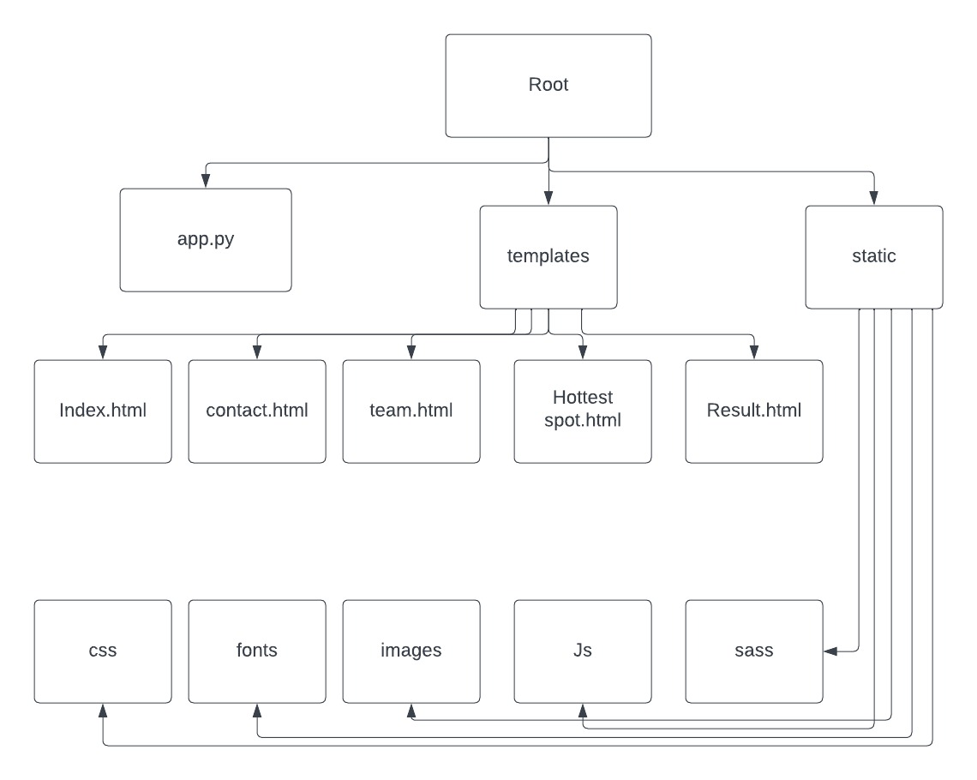

Figure 4. 1 File structure of the system.

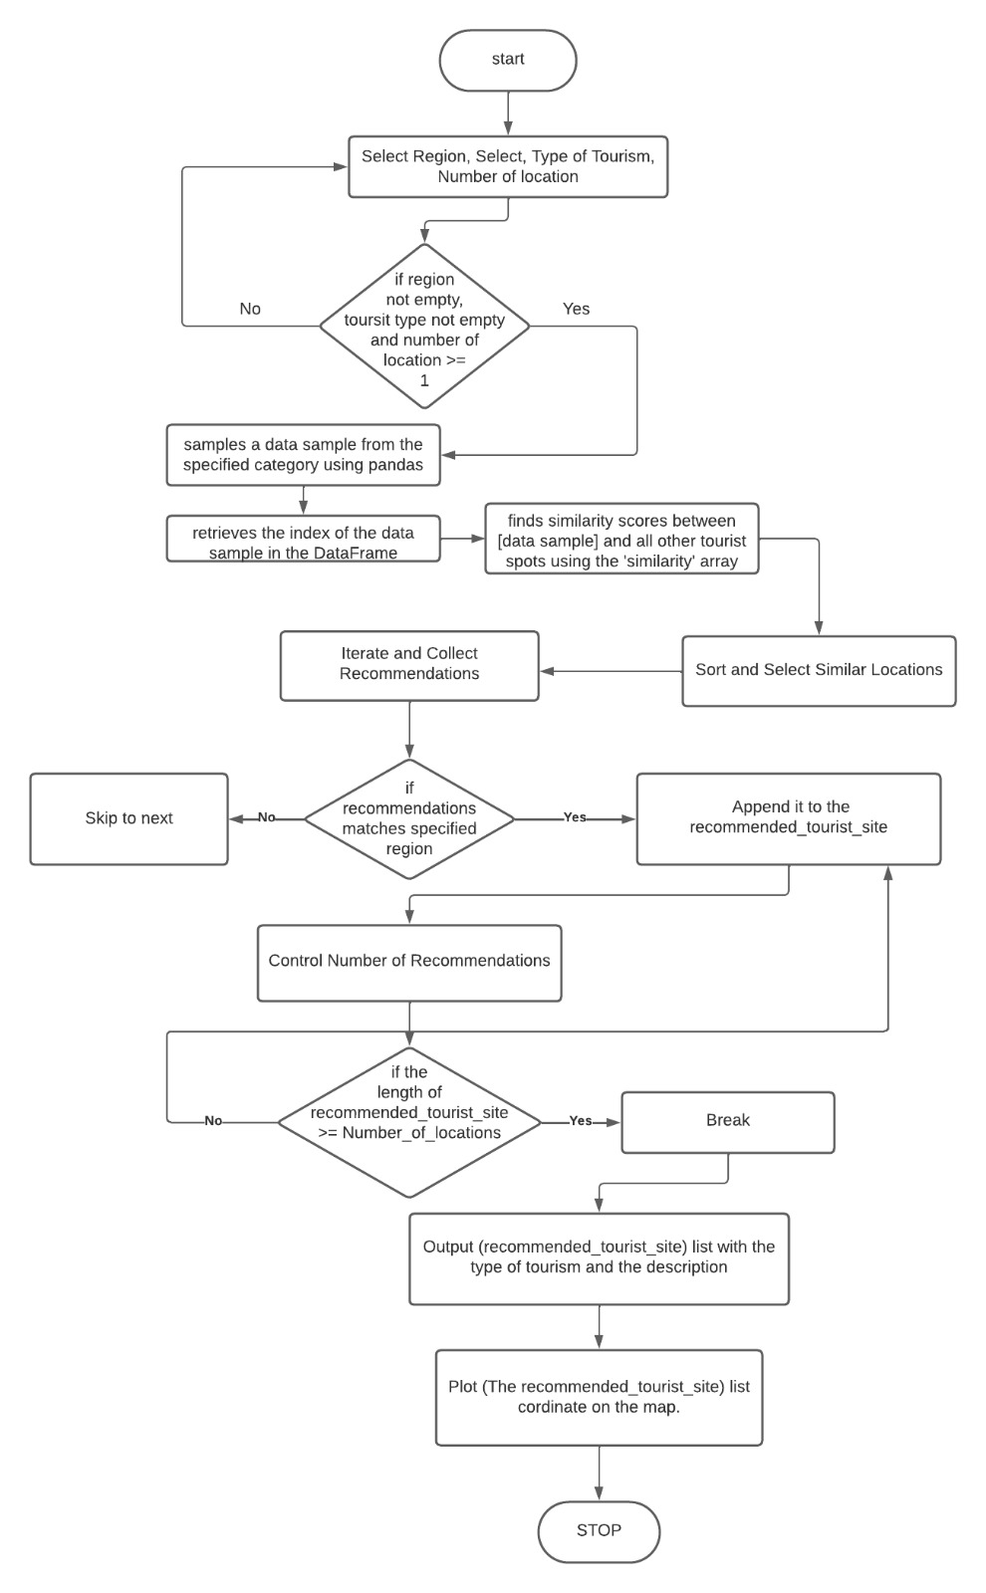

Figure 4. 2 Flow chart of the system.

## 4.5 System Features

The interfaces of the tourist-recommended system are depicted in the screenshots below as a guide to the system's operation.

## 4.5.1 Index Page



Figure 4. 3 Screen Shot of Index Page

The primary landing page for the travel website is this one. It has navigation, search capabilities with a region- and category-specific drop-down menu, the option to select the number of places, feature descriptions, and a footer with relevant links and information.

The full breakdown of the tourism categories of ecotourism, adventure, nature, heritage, and culture (Tourist Sites, n.d)

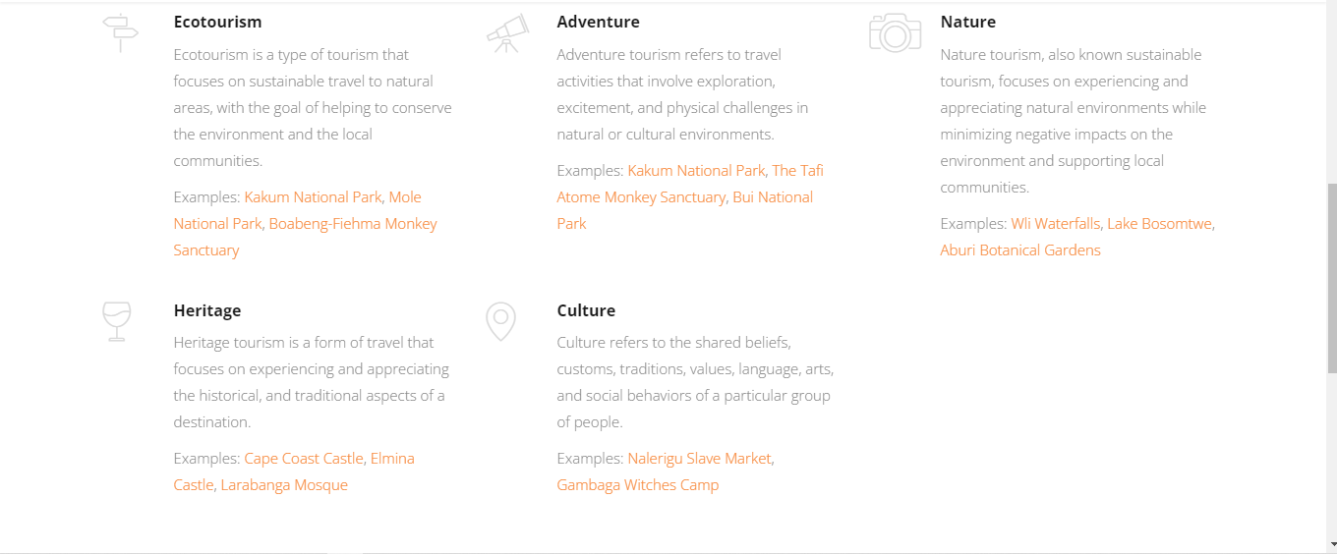

Figure 4. 4 Explanation of Categories.

Footer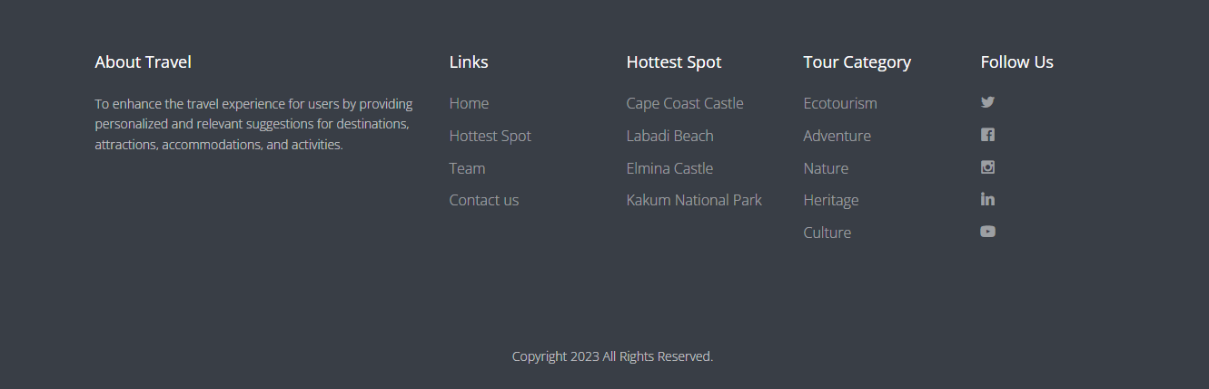

Figure 4. 5 Screenshot of Footer.

## 4.5.2 Hottest Spot Page

This page serves as a visually beautiful and user-friendly way to highlight some of the most popular tourist attractions, offer summaries of these locations, and entice visitors to learn more about each place.

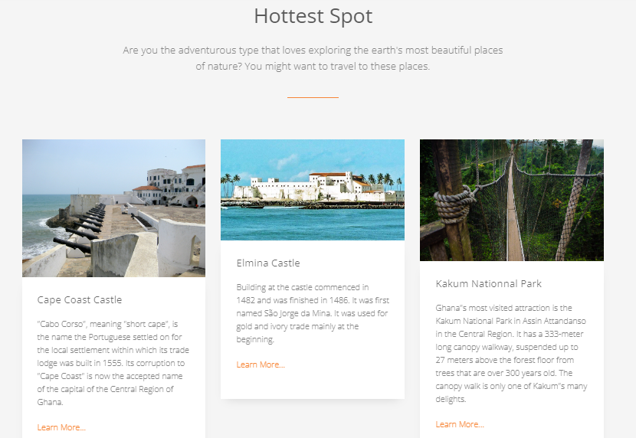

Figure 4. 6 Screenshot of Hottest Spot Page

## 4.5.3 Contact Us Page

Users can use this page to contact the website’s administrators and leave comments or ask questions. Its goal is to improve user experience by facilitating communication between the website and its visitors.

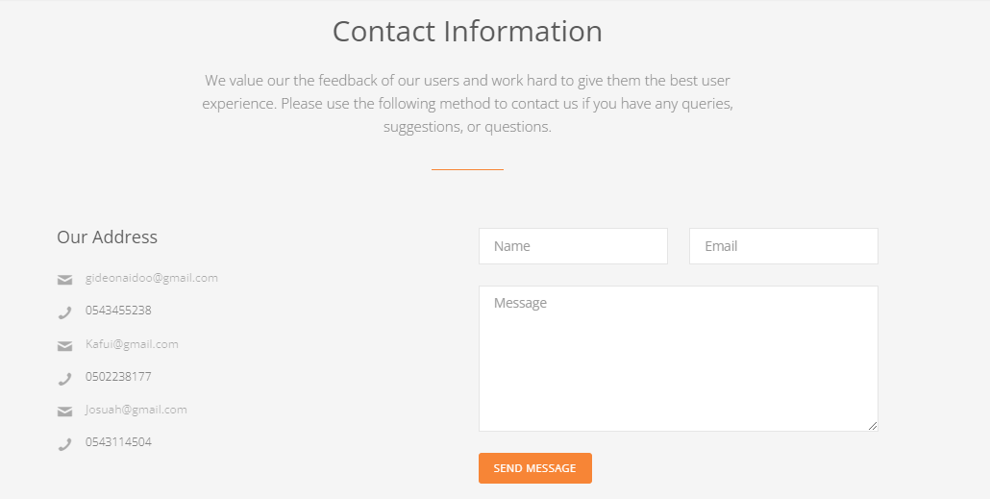

Figure 4. 7 Screenshot of Contact Us Page

## 4.5.4 Result Page



Figure 4. 8 Screenshot of Result Page

This page is intended to highlight suggested tourist attractions and a map for users interested in exploring other locations. It forms a part of a larger website that offers data and resources pertaining to tourism. With each suggested tourist attraction, a link to provide further information about the place.

The map pinpoints the exact location.

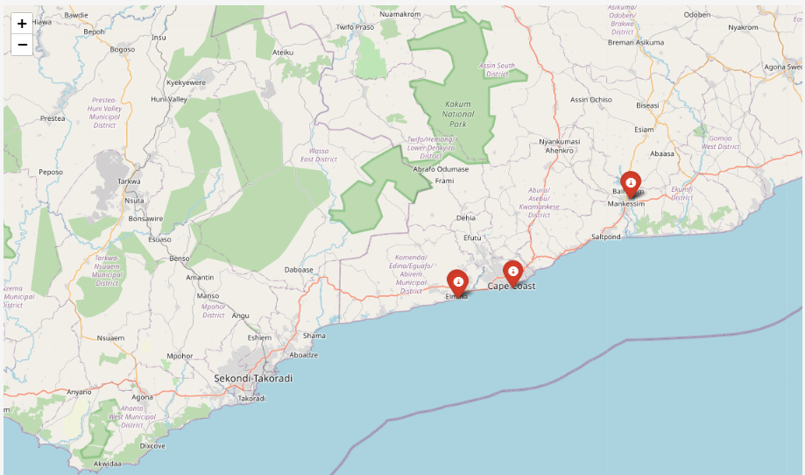

Figure 4. 9 Screenshot of Result Page Map

## 4.6 Summary

This chapter started with the requirement gathering and analysis processes that were used for this project. It then discusses in detail the flow of the system, the user of the system, and the various tasks the user can perform using a flow chart. It further discussed in detail each feature of the system and how it is used.

# CHAPTER FIVE

## EXPERIMENTATION AND ANALYSIS

## 5.1 Introduction

This section focuses on experimentation, data collection, and data analysis, primarily to find out if the tourism recommendation system is efficient in any way. The evaluation centered around appraising the systems using two specific criteria: the speed of execution and user satisfaction. The main goal of this study was to determine which of the two recommendation systems exhibited superior performance in terms of efficiency.

## 5.2 The Speed of Execution

Here is a comparative experiment that was performed on the travel recommendation system and the movie recommendation system (dataquestio, 2022). The experiment was centered around the system's speed of execution. This was done to find out which of the two uses the least amount of time in execution.

## 5.2.1 Graph Analysis

Table 5. 1 Dataset against Execution Time of Tourism Recommendation

|  |  |
| --- | --- |
| **DATASET SIZE** | **EXECUTION TIME (SECONDS)** |
| 10 | 0.0150 |
| 20 | 0.0190 |
| 30 | 0.0220 |
| 40 | 0.0210 |
| 50 | 0.0190 |
| 60 | 0.0190 |
| 70 | 0.0200 |
| 80 | 0.0200 |
| 90 | 0.0200 |
| 100 | 0.0180 |

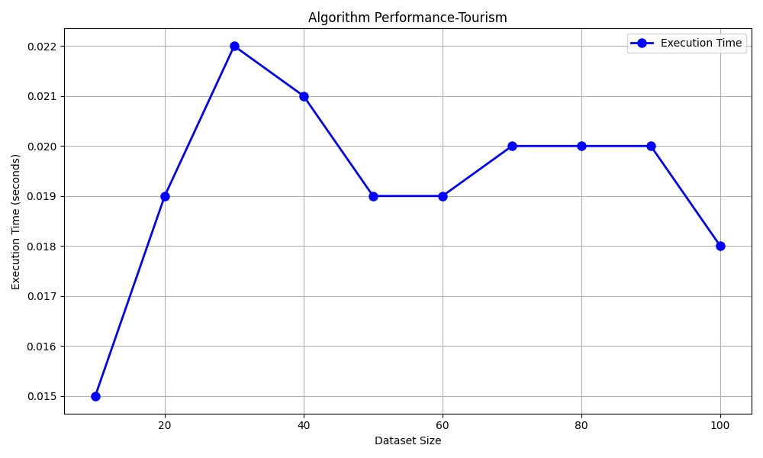

Figure 5. 1 Graph of Dataset against Execution Time of Tourism Recommendation System

Table 5. 2 Dataset against Execution Time of Movie Recommendation System

|  |  |
| --- | --- |
| **DATASET SIZE** | **EXECUTION TIME (SECONDS)** |
| 10 | 0.0100 |
| 20 | 0.0150 |
| 30 | 0.0210 |
| 40 | 0.0250 |
| 50 | 0.0290 |
| 60 | 0.0330 |
| 70 | 0.0350 |
| 80 | 0.0390 |
| 90 | 0.0420 |
| 100 | 0.0450 |

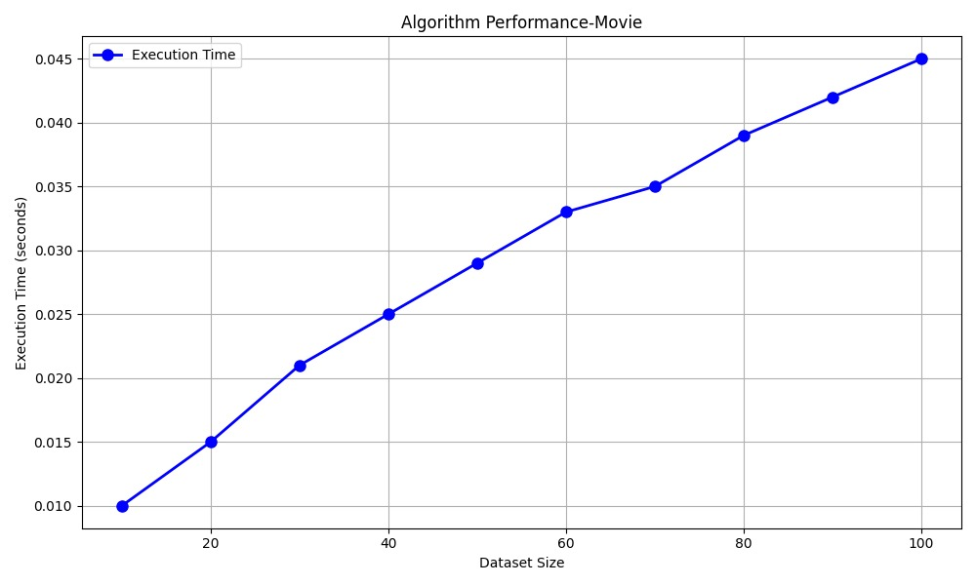

Figure 5. 2 Graph of Dataset against Execution Time of Movie Recommendation System

The data depicted in the graph was obtained through algorithmic testing using simulated data. The variables portrayed in the graph correspond to the number of outputs plotted against time in seconds.

Within the scope of the two scrutinized recommendation systems, the tourism recommendation system exhibits its lengthiest execution time at 0.022 seconds, observed during the generation of thirty outputs. Impressively, this time is 0.023 seconds faster than the highest recorded time of the movie recommendation system (dataquestio, 2022), which recorded 0.045 seconds for producing one hundred outputs.

After a thorough examination of the graph, it becomes evident that the graph for the movie recommendation system (dataquestio, 2022) consistently ascends with each subsequent rise in the output.

Regarding the travel recommendation system, the average execution time is 0.0193 seconds, representing an enhancement of 0.0101 seconds over the movie recommendation system (dataquestio, 2022), which reports an average time of 0.0294 seconds.

## 5.3 User Satisfaction

In this section, the focus shifts towards the results obtained from the survey, and a thorough examination of the insights they provide is conducted.

## 5.3.1 Data Collection

All data was collected using a Google form at the University of Cape Coast Campus. It consists of both quantitative and qualitative data. The participants for the survey were chosen using clustered random sampling. The survey was left open for a week and a total of sixty-seven (67) participants were obtained, all of whom engaged with both the tourism recommendation system and the movie recommendation system (dataquestio, 2022).

## 5.3.2 Data Results

The data obtained from the survey was analyzed using histograms. The interpretation of data has been drawn out in the section.

## 5.3.2.1 Participants

This section directs its attention to the findings derived from the survey, initiating a comprehensive analysis of the insights they offer. The survey enrolls a total of sixty-seven participants, each of whom has interacted with the tourism recommendation system and the movie recommendation system (dataquestio, 2022).

Figure 5. 3 Graph of Gender

Figure 5.3 Illustrates that most of the participants of the survey are male.

Figure 5. 4 How frequently do you use a recommendation system?

Figure 5.4 illustrates the distribution of recommendation system usage frequencies among the participants, classified as daily, first-time ever, monthly, rarely, or weekly. Upon scrutiny of the data, it becomes apparent that a noteworthy proportion of participants utilize a recommendation system infrequently. Among the participant cohort, the subgroup that employs a recommendation system monthly constitutes the least prominent segment.

## 5.3.2.2 Tourism Recommendation System

Figure 5. 5 On a scale from 1 to 5, how easy was it to understand and navigate the recommendation system?

Figure 5.5 offers insights into the ease-of-use perception of the tourism recommendation system among the participants, utilizing a scale from 1 to 5, where 1 represents very difficult and 5 indicates very easy. A significant number of participants opted for the rating of 5, signifying a notable degree of user-friendliness in their interactions.

Figure 5. 6 How accurate were the recommendations provided by the system?

Figure 5.6 imparts insights regarding the perceived accuracy level attributed by participants to the outcomes generated by the tourism recommendation system. Employing a scale wherein 1 symbolizes minimal accuracy and 5 signifies complete accuracy, the data underscores that a noteworthy proportion of participants favoured a rating of 4. This underscores a perception of moderate accuracy in the results, although not reaching the status of complete precision. Furthermore, a segment of participants chose a rating of 2, signifying their perception of the received outcomes as moderately inaccurate.

Figure 5. 7 Were the recommended items relevant to your interests or needs?

Figure 5.7 provides insights into participants' perceptions of the relevance of outcomes produced by the tourism recommendation system. Employing a scale where 1 represents 'no, completely irrelevant,' and 5 denotes 'yes, very relevant,' the data discloses that most participants perceived the results of the tourism recommendation system as markedly relevant. Interestingly, an equivalent number of participants expressed a neutral perspective or slight sense of irrelevance toward the outcomes.

Figure 5. 8 How satisfied are you overall with the recommendation system?

Figure 5.8 provides insights into the overall satisfaction levels of participants regarding the recommendation system, employing a scale where 1 represents 'very dissatisfied,' and 5 signifies 'very satisfied.' The data depicted in Figure 6 demonstrates that most participants conveyed a strong sense of satisfaction with the tourism recommendation system, while the least common sentiment was neutrality.

Figure 5. 9 Would you recommend our recommendation system to others?

Figure 5.9 offers insights into participants' inclinations to endorse the tourism recommendation system to others, gauged on a scale from 1 to 5, where 1 indicates 'definitely not,' and 5 signifies 'definitely.' The data presented in Figure 5.9 underscores that a substantial portion of participants selected ratings of 4 and 5, indicative of their inclination to recommend the tourism recommendation system to others. Nonetheless, a subset of participants indicated a rating of 2, suggesting that they may not be as proactive in sharing information about the tourism recommendation system.

Figure 5. 10 Do you have any suggestions or features you would like to see added to the recommendation system?

Figure 5.10 provides insights into the recommendations and desired enhancements put forth by participants for potential improvements to the tourism recommendation system. A noteworthy majority of the sixty-seven participants responded 'N/A,' indicating a lack of suggestions. For those participants who did contribute suggestions, an open coding approach was employed to categorize the feedback.

The suggestions were categorized as follows: Under 'Agencies,' participants proposed ideas related to collaborating with travel agencies to streamline trip bookings. The 'Category' category included suggestions advocating for the expansion of tourism categories. Suggestions falling under 'Description' revolved around enriching the level of detail in tourist site descriptions. 'Direction' encompassed a suggestion regarding participant awareness of their proximity to tourist sites. 'Output' included ideas concerning the presentation format of system-generated results. Lastly, 'Images' comprised suggestions urging the incorporation of images portraying tourist sites.

Figure 5. 11 What aspects of the recommendation system do you think need improvement?

Figure 5.11 offers insights into the aspects of the recommendation system that participants identify as necessitating improvement. A significant majority of participants submitted 'N/A' as their input, signifying a lack of suggestions. 'Ambiguous' was assigned to participants who found the dashboard to be unclear. The 'Details' category encompassed participants' recommendations aimed at enhancing the comprehensiveness of tourist site descriptions. 'Images' were associated with responses advocating for the incorporation of visual content within the results. 'Number' pertained to participant suggestions advocating for a reduction in the displayed count of tourist attractions. Finally, 'Repeat' included participant feedback expressing concerns about the recurrence of certain results.

## 5.3.2.3 Movie Recommendation System

Figure 5. 12 On a scale from 1 to 5, how easy was it to understand and navigate the recommendation system?

Figure 5.12 imparts insights into the perceived usability of the movie recommendation system (dataquestio, 2022) among the participants. Employing a scale from 1 to 5, where 1 signifies 'very difficult' and 5 denotes 'very easy,' the data exposes that a substantial majority of participants opted for a rating of 5. This suggests that the user experience was remarkably seamless and user-friendly for this group.

Figure 5. 13 How accurate were the recommendations provided by the system?

The accuracy of the outcomes produced by the movie recommendation system (dataquestio, 2022) is illustrated in Figure 5.13. Employing a scale from 1 to 5, where 1 represents minimal accuracy and 5 indicates complete precision, the data demonstrates that most respondents assigned a rating of 5, indicating a perception of absolute accuracy in the results. Furthermore, a subgroup of participants chose a rating of 2, signifying their perception of diminished accuracy in the outcomes they were provided.

Figure 5. 14 Were the recommended items relevant to your interests or needs?

Figure 5.14 provides an elucidation of the level of relevance assigned by participants to the outputs of the tourism recommendation system. Employing a scale that spans from 1, representing complete irrelevance, to 5, signifying high relevance, the data highlights that a substantial segment of respondents evaluated the outcomes of the movie recommendation system (dataquestio, 2022) as highly relevant. Notably, a small subgroup of participants, consisting of 4 individuals, expressed a perception of irrelevance in the results.

Figure 5. 15 How satisfied are you overall with the recommendation system?

Figure 5.15 offers insights into participants' general satisfaction with the movie recommendation system introduced by 'project-walkthroughs' in 2022. Utilizing a scale spanning from 1, representing significant dissatisfaction, to 5, indicating substantial satisfaction, the information presented in Figure 5.15 demonstrates that most participants exhibited a level of moderate satisfaction with the movie recommendation system (dataquestio, 2022). Furthermore, a small percentage of participants, constituting 7.5% of the total, indicated a minor degree of dissatisfaction.

Figure 5. 16 Would you recommend our recommendation system to others?

Figure 5.16 imparts insights into participants' inclinations to endorse the movie recommendation system (dataquestio, 2022) to others. This evaluation employs a scale ranging from 1 to 5, where 1 signifies 'definitely not' and 5 represents 'definitely.' The data from Figure 5.16 reveals that a substantial majority of participants selected a rating of 5, indicating their intent to recommend the movie recommendation system to others. Nonetheless, there were a few participants who indicated ratings of 1 and 2, implying that certain individuals might not be inclined to share information about the movie recommendation system (dataquestio, 2022) with others.

Figure 5. 17 Do you have any suggestions or features you would like to see added to the recommendation system?

Figure 5.17 offers insights into the diverse recommendations and desired enhancements that participants wish to see integrated into the movie recommendation system (dataquestio, 2022). Among the group of sixty-seven participants, a majority indicated 'N/A,' signifying a lack of suggestions. However, for those participants who did contribute suggestions, an open coding approach was employed to organize their input.

Suggestions that revolved around adding current movies or films from a variety of genres were classified under the "Database" category. "Details" was assigned to suggestions proposing the incorporation of more comprehensive information about the recommended movies into the movie recommendation system introduced by 'project-walkthroughs' in 2022. The "GUI" category encompassed suggestions aimed at improving the user interface of the movie recommendation system. Lastly, suggestions expressing a desire for movie trailers to accompany recommendations were grouped within the "Trailers" category.

Figure 5. 18 What aspects of the recommendation system do you think need improvement?

Figure 5.18 provides insights into the specific aspects of the recommendation system that participants perceive as requiring improvement. Within the participant group, a substantial majority indicated 'N/A,' indicating a lack of comments on this matter. For participants who did offer feedback, their responses were categorized as follows: "Database" was attributed to participants who recommended expanding the system's database to include movies not currently present. "Efficiency" encompassed responses highlighting the necessity for system reliability enhancements. The "Result limit" category pertained to participants who expressed concerns about understanding the recommendation limit and those desiring the system to surpass the established cap of ten recommendations. "UI" was linked with responses expressing discontent with the system's user interface.

Notably, following the N/A responses, those about the user interface garnered the highest frequency.

## 5.3.2.4 Summary

To determine the superior system according to participants, a table was generated using the positive responses from participants, specifically responses rated 4 and 5 on a scale of 1 to 5. The table is provided below.

Table 5. 3 Positive Dataset

|  |  |  |
| --- | --- | --- |
|  | Tourism Recommendation System | Movie Recommendation System |
| On a scale from 1 to 5, how easy was it to understand and navigate the recommendation system? | 85.07% | 76.12% |
| How accurate were the recommendations provided by the system? | 80.59% | 83.58% |
| Were the recommended items relevant to your interests or needs? | 79.10% | 79.14% |
| How satisfied are you overall with the recommendation system? | 85.07% | 82.09% |
| Would you recommend our recommendation system to others? | 94.03% | 59.70% |

Figure 5. 19 Positive Graph

Based on the data presented in Figure 5.19 regarding user satisfaction, the tourism recommendation system exhibits a greater number of positive responses across three subcategories when compared to the movie recommendation system (dataquestio, 2022).

In summary, it can be inferred that the tourism recommendation system is the movie recommendation system (dataquestio, 2022) and user satisfaction.

## 5.4 Conclusion

From all the data analysis done in this chapter, it can be said that the tourism recommendation system outperforms the movie recommendation system (dataquestio, 2022) in both speed of execution and user satisfaction. Therefore, making the tourism recommendation system more efficient than the movie recommendation system (dataquestio, 2022)

# CHAPTER SIX

# CONCLUSION AND FURTHER RECOMMENDATION

## 6.1 Conclusion

In conclusion, the developed recommendation system offers an efficient and interactive way for users to obtain information about tourism in Ghana. By leveraging a database, the recommendation system can effectively interpret user input, calculate similarities, and provide relevant recommendations. The system's design takes advantage of Python's libraries, such as folium, sci-kit-learn, pandas and flask, to create a seamless user experience. The implementation process involved several key steps, including data preprocessing, response selection, and database management. The recommendation system was carefully designed to ensure accurate predictions and meaningful interactions with users. Through rigorous testing and evaluation, the system has been efficient.

In summary, the recommendation system successfully achieves its goal of providing users with easy access to information about tourist attractions through a user-friendly and interactive interface. The combination of data management, and user interaction design makes the recommendation system a valuable tool for individuals seeking information about tourism in Ghana.

## 6.2 Recommendations for Future Works

We are thrilled to give this endorsement for the HERMES recommendation system, which our team worked tirelessly to develop. By emphasizing innovation, user-centric design, and cutting-edge recommendation methodologies, this project will substantially assist in providing users with accurate tourism destinations in Ghana. Because of its clear interface and vast database, this recommendation system demonstrates a true commitment to improving user experiences by responding to user inputs swiftly and correctly. In the proposal that follows, I will go into depth about the project's key benefits and the significant impact it has had on enhancing customer happiness, simplifying interactions, and casting more light on tourist destinations in general. This initiative is only intended to help tourists. Its purpose is to assist people in locating tourism sites that suit their preferences.

The Hermes recommendation system's great user experience, user-centric design, and seamless integration illustrate its critical role in improving user experiences and operational efficiency. With the possibility for continuing improvement, the recommendation is well-positioned to stimulate more beneficial developments. As staunch advocates of this initiative, we are confident that it will have a substantial impact.

# References

Alnogaithan, O., Algazlan, S., Aljuraiban, A., & Shargabi, A. A. (2019, September). *Tourism Recommendation System Based on User Reviews.* From IEEE Xplore: https://ieeexplore.ieee.org/document/8910312

Alrasheed, H., Alzeer, A., Alhowimel, A., Alshameri, N., & Althyabi, A. (2020). *A Multi-Level Tourism Destination Recommender System.* From Research Gate: https://www.researchgate.net/publication/340636521_A_Multi-Level_Tourism_Destination_Recommender_System

Badouch, M., & Boutaounte, M. (2023). *Personalized Travel Recommendation Systems: A Study of Machine Learning Approaches in Tourism.* From Research Gate: https://www.researchgate.net/publication/370274670_Personalized_Travel_Recommendation_Systems_A_Study_of_Machine_Learning_Approaches_in_Tourism

Basiri, M. E., Ghasem-Aghaee, N., & Naghsh-Nilchi, A. R. (2014). *Exploiting reviewers’ comment histories for sentiment analysis.* From Sage Journals: https://journals.sagepub.com/doi/10.1177/0165551514522734

Chen, L., Yang, Y., Wang, N., Yang, K., & Yuan, Q. (2019). *How Serendipity Improves User Satisfaction with Recommendations? A Large-Scale User Evaluation.* From ACM Digital Library: https://dl.acm.org/doi/10.1145/3308558.3313469

Dareddy, M. R. (2016). *Challenges in Recommender Systems for Tourism.* From Semantic Scholar: https://www.semanticscholar.org/paper/Challenges-in-Recommender-Systems-for-Tourism-Dareddy/bd31e1d96f7238c7224791418c5f85a85aa99f9f#citing-papers

dataquestio. (2022). *movie_recommendations.ipynb*. From githhub: https://github.com/dataquestio/project-walkthroughs/blob/master/movie_recs/movie_recommendations.ipynb

De Pessemier, T., Deryckere, Tom, & Martens, L. (2009). *Context aware recommendations for user-generated content on a social network site.* From ACM Digital Library: https://dl.acm.org/doi/10.1145/1542084.1542108

Erbil, E., & Wörndl, W. (2022). *Personalization of Multi-day Round Trip Itineraries According to Travelers’ Preferences.* From SpringerLink: https://link.springer.com/chapter/10.1007/978-3-030-94751-4_17#Abs1

Garcia, S., & Yin, P. (2015). User Review Sentiment Classification and Aggregation.

Hong, M., & Jung, J. J. (2021). *Multi-criteria tensor model for tourism recommender systems.* From Science Direct: https://www.sciencedirect.com/science/article/abs/pii/S0957417420311817

Krumm, J., Davies, N., & Narayanaswami, C. (2008). *User-Generated Content.* From IEEE Xplore: https://ieeexplore.ieee.org/document/4653465?denied=

Kuo, N.-T., Cheng, Y.-S., Chang, K.-C., & Chuang, L.-Y. (. (2018). *The Asymmetric Effect of Tour Guide Service Quality on Tourist Satisfaction.* From Taylor & Francis Online: https://doi.org/10.1080/1528008X.2018.1483283

Lak, P., & Turetken, O. (2017). *The Impact of Sentiment Analysis Output on Decision Outcomes: An Empirical Evaluation.* From Semantic Scholar: https://www.semanticscholar.org/paper/The-Impact-of-Sentiment-Analysis-Output-on-Decision-Lak-Turetken/13df23f6b43a904a332664790ebb31f43791e9ad

Mahdi, W., Soui, M., & Abed, M. (2014, May). *A new personalization approach by case-based reasoning and fuzzy logic.* From Reseatch Gate: https://www.researchgate.net/publication/269290880_A_new_personalization_approach_by_case-based_reasoning_and_fuzzy_logic

Matt, C., Benlian, A., Hess, T., & Weiß, C. (2014). *Escaping from the Filter Bubble? The Effects of Novelty and Serendipity on Users’ Evaluations of Online Recommendations.* From Econ Papers: https://econpapers.repec.org/paper/darwpaper/66193.htm

Mohan, S., Klenk, M., & Bellotti, V. (2019). *Exploring How to Personalize Travel Mode Recommendations For Urban Transportation.* From Research Gate: https://www.researchgate.net/publication/330400916_Exploring_How_to_Personalize_Travel_Mode_Recommendations_For_Urban_Transportation

Musterd, S., & Kovacs, Z. (2013). *Tailored - Context-Sensitive - Urban Policies for Creative Knowledge Cities.* From Research Gate: https://www.researchgate.net/publication/289709069_Tailored_-_Context-Sensitive_-_Urban_Policies_for_Creative_Knowledge_Cities

Narducci, F., Musto, C., Semeraro, G., Lops, P., & de Gemmis, M. (2013). *Exploiting Big Data for Enhanced Representations in Content-Based Recommender Systems.* From SpringerLink: https://link.springer.com/chapter/10.1007/978-3-642-39878-0_17

Niu, X., & Al-Doulat, A. (2021). *LuckyFind: Leveraging Surprise to Improve User Satisfaction and Inspire Curiosity in a Recommender System.* From ACM Digital Library: https://dl.acm.org/doi/abs/10.1145/3406522.3446017

Not, E., & Petrelli, D. (2014). *Balancing Adaptivity and Customisation.* From Research Gate: https://www.researchgate.net/publication/300572403_Balancing_Adaptivity_and_Customisation

Ojha, A. C., & Mishra, J. (2018). *Interest-Satisfaction Estimation Model for Point-of-Interest Recommendations in Tourism.* From IEEE Xplore: https://ieeexplore.ieee.org/document/8724131

*Pinheiro, J*. (n.d.). From Software Development Life Cycle (SDLC) Phases.: https://medium.com/@jilvanpinheiro/software-development-life-cycle-sdlc-phases-40d46afbe384

Ricci, F., Rokach, L., & Shapira, B. (2015). *Recommender Systems: Introduction and Challenges.* From Springer Link: https://link.springer.com/chapter/10.1007/978-1-4899-7637-6_1

Rossetti, M., Stella, F., & Zanker, M. (2016). *Analyzing user reviews in tourism with topic models.* From Ideas: https://ideas.repec.org/a/spr/infott/v16y2016i1d10.1007_s40558-015-0035-y.html

Schnabel, T., Bennett, P. N., Dumais, S. T., & Joachims, T. (2018). *Short-Term Satisfaction and Long-Term Coverage: Understanding How Users Tolerate Algorithmic Exploration.* From Research Gate: https://www.researchgate.net/publication/322971654_Short-Term_Satisfaction_and_Long-Term_Coverage_Understanding_How_Users_Tolerate_Algorithmic_Exploration

*Software Development Life Cycle (SDLC) - Overview*. (n.d.). From Tutorialspoint: https://www.tutorialspoint.com/sdlc/sdlc_overview.htm

Teh, P. L., Pak, I., Rayson, P., & Piao, S. (2015). *Exploring fine-grained sentiment values in online product reviews.* From Research Gate: https://www.researchgate.net/publication/282239839_Exploring_fine-grained_sentiment_values_in_online_product_reviews

Thomann, E. (2018). *Moving Beyond (Non-)compliance: Conceptualizing Customization.* From Semantic Scholar: https://www.semanticscholar.org/paper/Moving-Beyond-(Non-)compliance%3A-Conceptualizing-Thomann/b9fda9ca38773928d68e67f9daad4c916edb8a99

Tikkinen-Piri, C., Rohunen, A., & Markkula, J. (2018). *EU General Data Protection Regulation: Changes and implications for personal data collecting companies.* From Science Direct: https://www.sciencedirect.com/science/article/abs/pii/S0267364917301966

Tintarev, N., Flores, A., & Amatriain, X. (2010). *Off the beaten track - A mobile field study exploring the long tail of tourist recommendations.* From Research Gate: https://www.researchgate.net/publication/221270502_Off_the_beaten_track_-_A_mobile_field_study_exploring_the_long_tail_of_tourist_recommendations

*Tourist Sites*. (n.d). From Motac: https://www.motac.gov.gh/tourist-sites/

Valentine, L., D’Alfonso, S., & Lederman, R. (2022, January). *Recommender systems for mental health apps: advantages and ethical challenges.* From Springer Link: https://link.springer.com/article/10.1007/s00146-021-01322-w#Sec8

*What-is-agile-scrum-methodology*. (n.d). From upgard: https://www.upgrad.com/blog/what-is-agile-scrum-methodology/

WTTC. (2019). *Economic Impact Research.* From World Travel & Tourism Council: https://wttc.org/research/economic-impact

Yin, C.-Y., & Poon, P. (2016). *The impact of other group members on tourists’ travel experiences: A study of domestic package tours in China.* From Emerald Impact: https://www.emerald.com/insight/content/doi/10.1108/IJCHM-07-2014-0340/full/html